**Doddington and District Parish Council**

17 Robert Street, Northwich, Cheshire, CW8 1DN

T: 07393 328 473 E:clerk@doddingtondistrict.org.uk

7th July 2023

You are invited to a meeting of Doddington and District Parish Council to be held at Hankelow Methodist Hall on 17th July 2023 at 7.30 pm for the transaction of the business below.

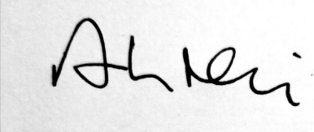

Arthur Neil

**Clerk to the Council**

**Doddington and District Parish Council Ordinary Meeting**

**17th July 2023 7.30 pm**

**Agenda**

1. Apologies for absence
2. Declarations of Members’ Interests
3. Minutes of the November meeting
4. Payments  
   Clerk Salary – two months- £241.20  
   David Owen – Internal Audit £100.00

ThenMedia £24.00  
Expenses – postaqe stamps £14.80, scanning £31.00, mileage 45.00  
Community Heartbeat Trust maintenance of defib £198.00  
Zurich Insurance £406.31 (previously approved)

1. Audit Report and AGAR
2. Co-options
3. Planning Applications and decisions
4. Website
5. Ward Borough Councillor’s Report
6. Individual members’ reports