DODDINGTON PARISH COUNCIL

VACANCY FOR COUNCILLORS

There are vacancies for two Councillors for the East Ward of the Parish of Doddington

The Council can fill the two vacancies by co-option .

If you wish to be considered for nomination as a councillor for this ward please contact the clerk by email or phone not later than 10th
July

Date 25th June 2023

Signed 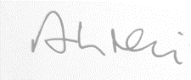 Arthur Neil

(Clerk)

Email clerk@doddingtondistrict.org.uk

Tel 07393 328 473

